PT participation registration form
- Name of the participant Laboratory/ Organization:

- Contact person Details:
Name : Designation :
Mobile No. :
Email Id :
- Complete Postal Address (For Dispatch of PT Material):
*(Building No, street No, area, city, district, state, country, pin code)

- Participant’s GSTIN (For Invoice) :

- Interested to participate in PT Round No(s):

- Payment details:
Mode of payment : DD/Cheque /RTGS/NEFT Amount paid :
Transection ID/No. : Date of payment : 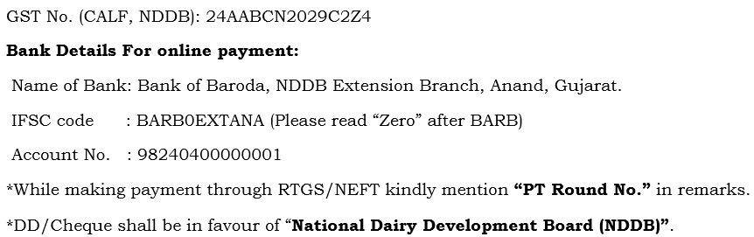
*Participation fees shall be paid in advance to conform the registration.

